Ordinal numbers template
You can use this functionality in your document by deleting the field first. Copy past the complete block into your template. Insert a new used date field from your new document and set the format of the used date field to “d” in the first field code calculation. (as described in the article)
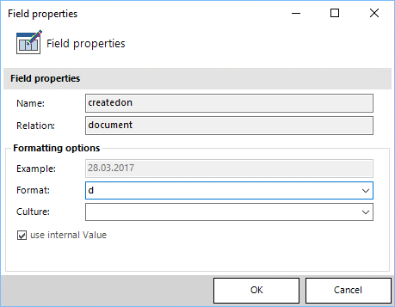

SOLUTION - Normal
<<createdon_ovalue>><<createdon_ovalue>>00,00,0

SOLUTION – Superscript
The difference between the normal and superscript version is that the part responsible for print the characters is set to superscripted (everything behind { day })
<<createdon_ovalue>><<createdon_ovalue>>^{00,00,0}

SOLUTION – Created date + Month + Day
The difference between the normal and this version is that there is another field added that shows the creation day and month. (In this case, Ordinal number of Month, Year.)
<<createdon_ovalue>><<createdon_ovalue>> 00,00,0 of <<createdon_ovalue>>, <<createdon_ovalue>>

